# Denmark – Source URL Analysis

**Source URL (Lovtidende):** <https://www.lovtidende.dk/>

**Alternative (Retsinformation)**: <https://www.retsinformation.dk/>

## Overview

### Lovtidende (Official Gazette)

Lovtidende is the official Danish government gazette through which the government announces new laws and regulations. It is organized into three main sections: Lovtidende A, B, and C.

* Lovtidende A – contains the broadest and most frequently referenced legal materials, including parliamentary acts (lov), consolidated acts (lovbekendtgørelser), statutory orders (bekendtgørelser), circulars (cirkulære), etc. Relevant ESG laws and regulations are primarily published in this section.
* Lovtidende B – focuses on financial and budgetary laws of the state. Lovtidende legislation text are downloadable files so automation of metadata extraction is not possible for this section.
* Lovtidende C – features international agreements and treaties to which Denmark is a party, including environmental and human rights treaties that may support ESG frameworks.

However, Lovtidende has significant functional limitations. Most notably, its searchable content is restricted to the years 2008 through 2025. Legal texts issued before 2008 are not accessible through this platform unless they have been republished during that time as consolidated acts.

For example, we tried searching for the “Act on Freedom of Association in the Labour Market” using the keyword “Foreningsfrihed” (Freedom of Association), but it did not return any results even though Lovtidende A, B, and C were already selected. This is because the “Act on Freedom of Association in the Labour Market” was originally passed in [1982](https://www.retsinformation.dk/eli/lta/1982/285), and its most recent consolidated version was issued in [2006](https://www.retsinformation.dk/eli/lta/2006/424), which falls outside Lovtidende’s searchable time range of 2008–2025.

In addition, Lovtidende has no advanced search feature for filtering relevant matches. It does not display detailed metadata for each law. The platform provides access to the text or PDF of the legislation as downloadable file, but crucial information such as the type of regulation, date of adoption, and entry into force date must be obtained from [retsinformation.dk](https://www.retsinformation.dk/).

### Retsinformation (Legal Information)

Retsinformation is the Danish government’s official legal information system and the most comprehensive public database for national legislation in Denmark. It provides centralized access to laws, statutory orders, circulars, statements, guidance, legal decisions, and parliamentary documents. It is organized into three search areas:

* Regler (Rules) – ESG-related laws and regulations are present within this area. It includes content from Official Gazette parts A, B and C as published in Lovtidende.
* Afgørelser (Decisions) – This area includes legal decisions, administrative rulings, and case law summaries issued by public authorities or courts. It does not contain the legislation itself, but rather applications of the law.
* Lov- og beslutningsforslag mv. (Bills and Resolutions, etc.) – This area contains proposed laws, parliamentary resolutions, and related preparatory documents that have not yet been adopted or promulgated.

A defining feature of Retsinformation is its [advanced search feature](https://www.retsinformation.dk/extremesearch?d=true&o=40&p=1&ps=10&q=%7B%22type%22%3A%22group%22%2C%22id%22%3A%220985DB6C-9E5B-430F-9BA6-DEAAD7CD0091%22%2C%22children1%22%3A%7B%2255434E1C-8DD2-4C46-9082-813902814890%22%3A%7B%22type%22%3A%22rule%22%2C%22properties%22%3A%7B%22field%22%3Anull%2C%22operator%22%3Anull%2C%22value%22%3A%5B%5D%2C%22valueSrc%22%3A%5B%5D%7D%7D%7D%2C%22properties%22%3A%7B%22conjunction%22%3A%22AND%22%7D%7D) for filtering search results and its extensive time coverage, with searchable content dating from 1665 to the present.

For example, we searched for the same legislation titled “Act on Freedom of Association in the Labour Market” using the same keyword Foreningsfrihed (Freedom of Association) within the Regler (Rules) section. The search returned [a result](https://www.retsinformation.dk/extremesearch?d=true&o=40&p=1&ps=10&q=%7B%22type%22%3A%22group%22%2C%22id%22%3A%22ab889989-0123-4456-b89a-b16f139daa93%22%2C%22children1%22%3A%7B%22b8b9b9a9-cdef-4012-b456-716f139daa93%22%3A%7B%22type%22%3A%22rule%22%2C%22properties%22%3A%7B%22field%22%3A%22retsinfoklassifikationId%22%2C%22operator%22%3A%22select_equals%22%2C%22value%22%3A%5B%22SortIndicator_10_40%22%5D%2C%22valueSrc%22%3A%5B%22value%22%5D%2C%22valueType%22%3A%5B%22select%22%5D%7D%7D%2C%22aaba9aa8-cdef-4012-b456-716fc3780da3%22%3A%7B%22type%22%3A%22rule%22%2C%22properties%22%3A%7B%22field%22%3A%22dokumentTypeId%22%2C%22operator%22%3A%22select_equals%22%2C%22value%22%3A%5B%22SortIndicator_30%22%5D%2C%22valueSrc%22%3A%5B%22value%22%5D%2C%22valueType%22%3A%5B%22treeselect%22%5D%7D%7D%2C%229bba98ba-cdef-4012-b456-716fc37a4f30%22%3A%7B%22type%22%3A%22rule%22%2C%22properties%22%3A%7B%22field%22%3A%22titel%22%2C%22operator%22%3A%22starts_with%22%2C%22value%22%3A%5B%22Foreningsfrihed%22%5D%2C%22valueSrc%22%3A%5B%22value%22%5D%2C%22valueType%22%3A%5B%22text%22%5D%7D%7D%7D%2C%22properties%22%3A%7B%22conjunction%22%3A%22AND%22%7D%7D) classified under the document type Lovbekendtgørelser (Consolidated Act). Please note that the document type was initially shown as “Legislative Decree” due to the browser’s built-in Google Translate, which can sometimes provide misleading translations.

Unlike Lovtidende, Retsinformation includes full metadata for each legal act and is the correct source for metadata extraction.

## Extraction of Metadata

We used the Retsinformation platform instead of Lovtidende and utilized only the Regler (Rules) section for the retrieval of relevant ESG legislation.

We entered ESG-related keywords in Danish (e.g., Foreningsfrihed for “[Act on Freedom of Association in the Labour Market](https://www.retsinformation.dk/eli/lta/2006/424)”) without quotation marks and found they consistently returned relevant matches. Keyword matches were pulled from the title of the legislation text.

The search results list only displays the original title. We extracted the full metadata on its legislation page (please refer to the screenshot after the bullet items). The type of regulation and the date of adoption were extracted by clicking Yderligere oplysninger (Additional information) in the upper right corner just below the legal citation. The metadata was determined as follows:

* **Source Link** – the URL of the legislation text.
* **Original Title** – the title displayed on the legislation page, labeled in red.
* **Type of Regulation** – inferred from the document type, labeled in green with the following terms:
* Lov – Act
* Lovbekendtgørelse /LBK – Consolidated Act
* Bekendtgørelse /BEK – Executive Order
* Bekendtgørelse (international) / BKI – Executive Order (International)
* Cirkulære / CIR – Circular
* Vejledning / VEJ – Guidance
* **Date of Adoption** – inferred from the Dato for underskrift (Date of signature), labeled in blue.

For KLI: We used the Date of Signature as Date of Adoption as it appears in the legal citation, which we understand it as the formal enactment of the law. Could you please confirm if our understanding is correct?

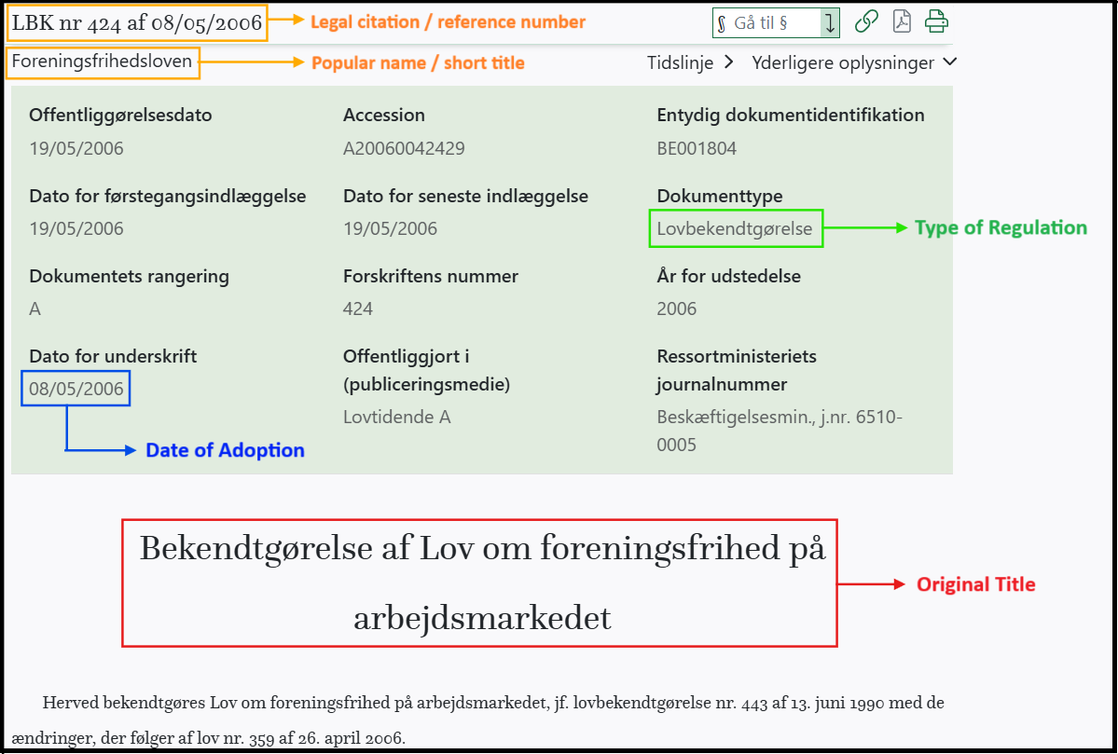

* **Entry into Force Date** – found within the body of the text, usually at the end of the legal document, in a section explicitly titled “Ikrafttræden” or “Ikrafttrædelse” (Entry into force).

For example:

[Environmental Protection Act (LAW No. 358 of 06/06/1991)](https://www.retsinformation.dk/eli/lta/1991/358) (Original Act)

Date of Adoption: 6 June 1991

Entry into Force: 1 January 1992

For consolidated acts (LBKs), these do not include a new entry into force date because they compile previous laws. In such cases, the entry into force date stated within the document reflects that of the original law. For example:

[Environmental Protection Act (LBK no. 1093 of 11/10/2024)](https://www.retsinformation.dk/eli/lta/2024/1093) (Current Consolidated Act)

Date of Adoption: 10 November 2024

Entry into Force: 1 January 1992

For KLI: Could you please confirm that our interpretation is correct?

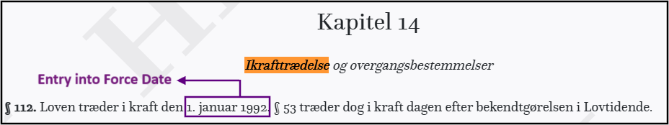

Additional Notes:

* + If the section “Ikrafttræden” or “Ikrafttrædelse” (Entry into force) does not specify a date, we left entry into force field blank. For example, in the [Climate Act](https://www.retsinformation.dk/eli/lta/2020/965), no date is provided under the Entry into force section.

* + If a particular legislation does not explicitly mention a section “Ikrafttræden” or “Ikrafttrædelse” (Entry into force), we also left this information blank.